Architectural Components – Request

📝Definition
# Source: AI Source: Provided by: [Data Path: Persons Table -> ID Column: 1, Name_En Column: Motasem Essam] -> From: [ChatGPT] on [1/23/2026]
A Request represents the input sent to the application from a user, client, or another system. It carries the data and intent of an action that the system needs to process.
👉 Think of a Request as the starting point of any operation — it tells the system what the user wants to do.

🔑 Responsibilities of a Request
# Source: AI Source: Provided by: [Data Path: Persons Table -> ID Column: 1, Name_En Column: Motasem Essam] -> From: [ChatGPT] on [1/23/2026]
- Carry input data (form data, JSON, query params)
- Represent a user action or intention
- Perform validation (in structured architectures)
- Provide a clean contract between client and backend

🧱 Examples

1️⃣ HTTP Request Example
# Source: AI Source: Provided by: [Data Path: Persons Table -> ID Column: 1, Name_En Column: Motasem Essam] -> From: [ChatGPT] on [1/23/2026]
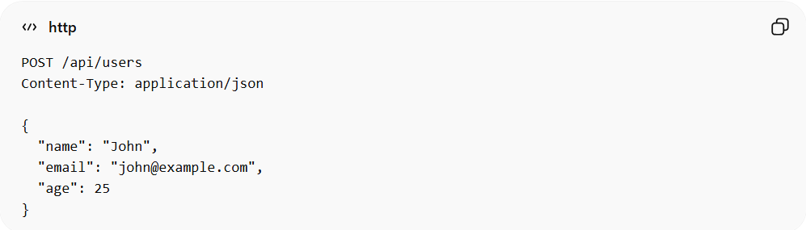
POST /api/users
Content-Type: application/json

{
"name": "John",
"email": "john@example.com",
"age": 25
}
👉 This request means:
- “Create a new user with this data”

2️⃣ Laravel Request Example (Form Request)
# Source: AI Source: Provided by: [Data Path: Persons Table -> ID Column: 1, Name_En Column: Motasem Essam] -> From: [ChatGPT] on [1/23/2026]
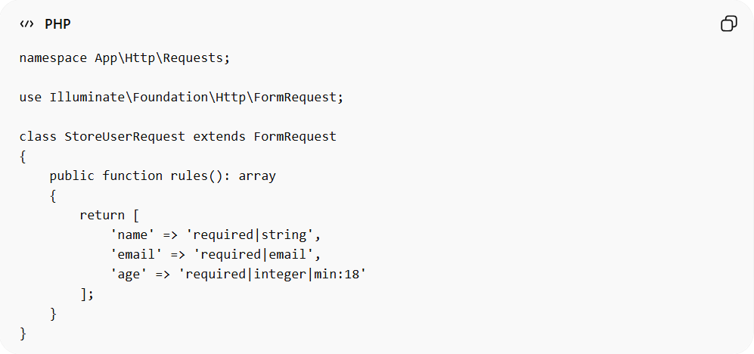
namespace App\Http\Requests;

use Illuminate\Foundation\Http\FormRequest;

class StoreUserRequest extends FormRequest
{
public function rules(): array
{
return [
'name' => 'required|string',
'email' => 'required|email',
'age' => 'required|integer|min:18'
];
}
}
Usage in Controller:
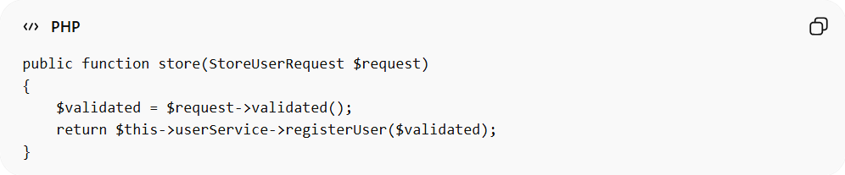
public function store(StoreUserRequest $request)
{
$validated = $request->validated();
return $this->userService->registerUser($validated);
}

❌ Bad Example
# Source: AI Source: Provided by: [Data Path: Persons Table -> ID Column: 1, Name_En Column: Motasem Essam] -> From: [ChatGPT] on [1/23/2026]
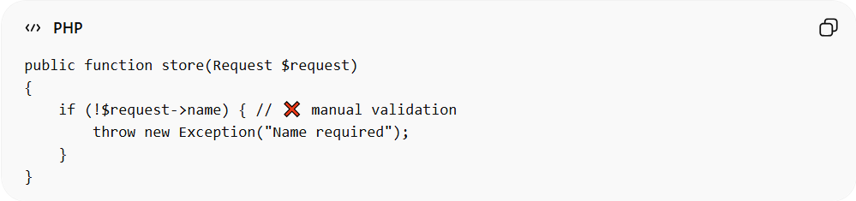
public function store(Request $request)
{
if (!$request->name) { // ❌ manual validation
throw new Exception("Name required");
}
}
Problems:
- Validation scattered in controller ❌
- Hard to reuse ❌
- Not clean ❌

✅ Good Example
# Source: AI Source: Provided by: [Data Path: Persons Table -> ID Column: 1, Name_En Column: Motasem Essam] -> From: [ChatGPT] on [1/23/2026]
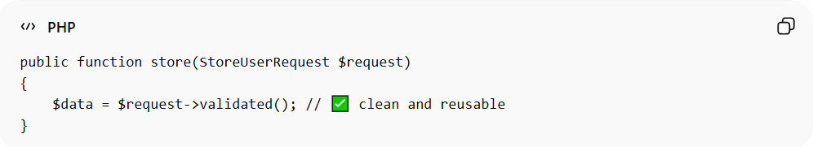
public function store(StoreUserRequest $request)
{
$data = $request->validated(); // ✅ clean and reusable
}
- Validation is separate and reusable ✅
- Controller is clean and focused ✅

🔄 Request in Architecture Flow
# Source: AI Source: Provided by: [Data Path: Persons Table -> ID Column: 1, Name_En Column: Motasem Essam] -> From: [ChatGPT] on [1/23/2026]
Client → Request → Controller → Service → Model → Resource → Response
👉 The Request is the entry point of this flow

🔄 Relation to Other Components
# Source: AI Source: Provided by: [Data Path: Persons Table -> ID Column: 1, Name_En Column: Motasem Essam] -> From: [ChatGPT] on [1/23/2026]
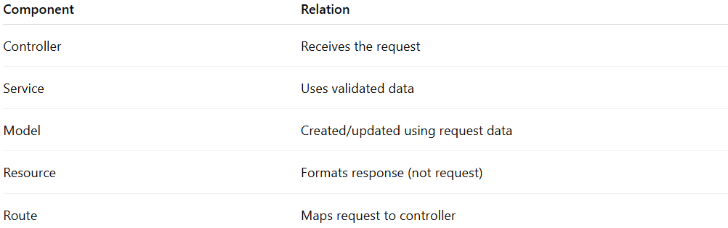
Component | Relation
Controller | Receives the request
Service | Uses validated data
Model | Created/updated using request data
Resource | Formats response (not request)
Route | Maps request to controller

⚠️ Common Mistakes
# Source: AI Source: Provided by: [Data Path: Persons Table -> ID Column: 1, Name_En Column: Motasem Essam] -> From: [ChatGPT] on [1/23/2026]
- Putting validation in Controller ❌
- Passing raw request everywhere ❌
- Mixing request with business logic ❌

💡 Key Idea
# Source: AI Source: Provided by: [Data Path: Persons Table -> ID Column: 1, Name_En Column: Motasem Essam] -> From: [ChatGPT] on [1/23/2026]
A Request represents user input and intent, and should be validated and structured before reaching business logic.

🧾 Summary
# Source: AI Source: Provided by: [Data Path: Persons Table -> ID Column: 1, Name_En Column: Motasem Essam] -> From: [ChatGPT] on [1/23/2026]
- Represents incoming data and actions
- Entry point of the system
- Should be validated and structured
- Keeps controllers clean and maintainable

